** Evaluation Handbook**

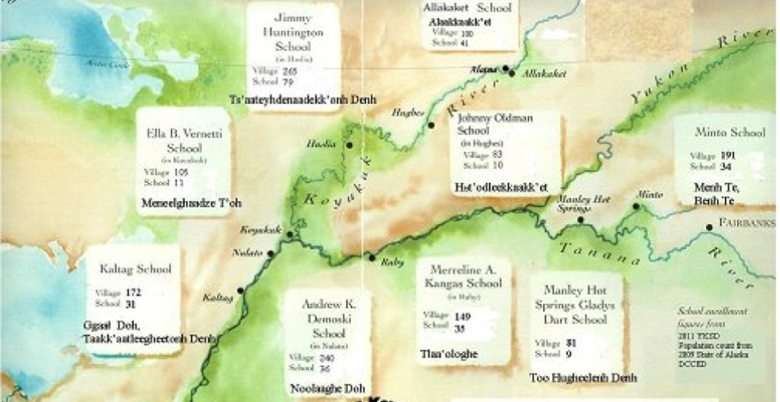

**Yukon Koyukuk School District**

**2015-2016**



**Teacher Evaluation Committee Meetings**

Teacher Evaluation Committee met several times during the 2013-14 and 2014-15 school years in order to create the Yukon Koyukuk School District Teacher Evaluation Plan.

**2013-14**

November 21-22

February 6-7

April 17-18

June 2-3

**2014-15**

October 21-22

December 12

February 25-27

**Teacher Evaluation Committee Members**

Scott Brucker – Special Education Teacher

Michele Sturdevant – Special Education Teacher

Casey Weter – Teacher / Principal

Peggy Bruno - Teacher

Joy Shier – Teacher

Anne Titus – Principal/ Parent

Joan Jones - Teacher / Union Representative

Heidi Wright – Teacher / Parent

Terri Thurston – Teacher

Jason Johnson – Teacher/ Principal

Laurie Beam – Supervisor of Federal Programs / Principal

Patty White – Director of Assessment / Principal

Andrea Cottrell – Director of Distance Education

Chane Beam – Director of Curriculum and Instruction

**Table of Contents**

**Introduction…………………………………..................…………..……………………………………………4**

**Rationale………………………………….................….………………………….…..………………………… 4**

**The YKSD Smart Card………………………………….…………………………..……………………………… 7**

**Stakeholder Participation…………….................………………………….……………………………… 7**

**Content Standards………………….................….………………………..………………………………… 8**

**Cultural Standards…………………………………….…………………………………..……….……………… 9**

**Performance Standards……………….................…………………..……………….…………………… 9**

**Levels of Performance…………………..............……………………..…………………………………… 10**

**General Description of the Four Ratings of Professional Practice…………………….……..10**

**Observation Tool…………………………….................………………………..……………………………11**

**Student, Parent and Community Input...............…………………………..……………………… 11**

**Other Information……………………………………………………………………………………………..… 12**

**Teacher Training…………………….................…………………………..…………………………………12**

**Evaluator Training and Inter-rater Reliability Training......………………..…………..……… 12**

**Student Learning Objectives………………………………………………………….…………………..… 13**

**Professional Growth and Improvement of Effective Instruction......……………………… 15**

**Non-Retention…………………….................…………………………………………………………….… 16**

**Overall Rating………………………………………………………………….……………………..…………… 16**

**Introduction**

The Yukon Koyukuk School District recognizes the complexity of teaching and the importance of each staff member’s performance to the growth of children. The design of our evaluation plan is to provide a constructive, cooperative, and continuing process for improving the quality of instruction for the children of the district. Ultimately, this evaluation system is highly individualized and includes informal daily experiences and interactions, as well as formal observations and discussions between the staff member and evaluator. Through reflection, coaching and collaboration, the evaluation process supports staff members in recognizing and understanding their strengths and areas for growth as they relate to their professional responsibilities.

Our evaluation system utilizes the frameworks for teaching taken from the research of Charlotte Danielson (*Enhancing Professional Practice: A Framework for Teaching, 2nd edition).*  The Danielson Framework is based on empirical studies and theoretical research regarding both teaching and learning. Using an agreed-upon framework helps to structure conversations about performance to guide novice staff members and enhance the performance of veteran staff members. The four domains of teaching responsibility are the following:

* **Domain 1**: Planning and Preparation
* **Domain 2**: The Classroom Environment
* **Domain 3**: Instruction
* **Domain 4**: Professional Responsibilities

Within each domain are components that define a distinct area of the domain. The Yukon Koyukuk School District has chosen to implement twelve of the Danielson components. Each component is further broken down into more specific and distinct elements. Taken together, the domains, components, and elements constitute a comprehensive framework reflecting the many different aspects of teaching. Although distinct, each area of the framework is interrelated.

**Rationale**

**Teacher Evaluation**

An effective system of teacher evaluation accomplishes two things: it ensures quality teaching and it promotes the professional learning of the educators. The quality of teaching is the single most important determinant of student learning and a school district’s system of teacher evaluation is the method by which it ensures that teaching is of high quality. Therefore, the system developed for teacher evaluation must rigorous, valid, reliable, and defensible, and must be grounded in a research‐based and accepted definition of good teaching. Charlotte Danielson’s *Framework for Teaching* provides such a foundation. Additionally, YKSD believes the procedures used in teacher evaluation can be used to promote professional learning. When teachers engage in self‐assessment, reflection on practice, and professional conversation, they become more thoughtful and reflective about their instructional skills and are in a position to improve their teaching. Evaluators can contribute to teachers’ professional learning through the use of coaching and/or in‐depth reflective questions. By shifting the focus of evaluation from “inspection” to “collaborative reflection and coaching” educators can ensure the maximum benefit from the evaluation activities.

**Classroom Observation**

Classroom observation is a professional learning opportunity for both teachers and administrators. Typically associated with supervision and evaluation, it provides essential evidence of classroom practice, and how a teacher’s actions reflect the components of the twelve components implemented by YKSD*.* However, observation skills are also used by mentors and coaches as they serve as “another set of eyes” for coaching a teacher. As YKSD moves along the continuum and this process evolves into a “coaching” model rather than an “evaluation” model, the culture of coaching will grow in our district.

The YKSD Model for Effective Teaching Practices will include at a minimum two 30-minute formal observations and informal walkthroughs that will occur at least twice each month. Each of these must be followed up with feedback for the teacher.

**Alaska Statute ‐ AS 14.20.149 - Employee Evaluation.**

**(a)** A school board shall adopt, by July 1, 1997, a certificated employee evaluation system for evaluation and improvement of the performance of the district's teachers and administrators. The evaluation system applies to all the district's certificated employees except the district's superintendent. A school board shall consider information from students, parents, community members, classroom teachers, affected collective bargaining units, and administrators in the design and periodic review of the district's certificated employee evaluation system. An evaluation of a certificated employee under this section must be based on observation of the employee in the employee's workplace.

**(b)** The certificated employee evaluation system must

**(1)** establish district performance standards for the district's teachers and administrators that are based on professional performance standards adopted by the department by regulation;

**(2)** require at least two observations for the evaluation of each non-tenured teacher in the district each school year;

**(3)** require at least an annual evaluation of each tenured teacher in the district who met the district performance standards during the previous school year;

**(4)** permit the district to limit its evaluations of tenured teachers who have consistently exceeded the district performance standards to one evaluation every two school years;

**(5)** require the school district to perform an annual evaluation for each administrator;

**(6)** require the school district to prepare and implement a plan of improvement for a teacher or administrator whose performance did not meet the district performance standards, except if the teacher's or administrator's performance warrants immediate dismissal under AS 14.20.170(a);

**(7)** provide an opportunity for students, parents, community members, teachers, and administrators to provide information on the performance of the teacher or administrator who is the subject of the evaluation to the evaluating administrator.

**(c)** A person may not conduct an evaluation under this section unless the person holds a type B certificate or is a site administrator under the supervision of a person with a type B certificate, is employed by the school district as an administrator, and has completed training in the use of the school district's teacher evaluation system.

**(d)** Once each school year, a school district shall offer in‐service training to the certificated employees who are subject to the evaluation system. The training must address the procedures of the evaluation system, the standards that the district uses in evaluating the performance of teachers and administrators, and other information that the district considers helpful.

**(e)** A school district shall provide a tenured teacher whose performance, after evaluation, did not meet the district performance standards with a plan of improvement. The evaluating administrator shall consult with the tenured teacher in setting clear, specific performance expectations to be included in the plan of improvement. The plan of improvement must address ways in which the tenured teacher's performance can be improved and shall last for not less than 90 workdays and not more than 180 workdays unless the minimum time is shortened by agreement between the evaluating administrator and the teacher. The plan of improvement shall be based on the professional performance standards outlined in the locally adopted school district evaluation procedure. The school district must observe the teacher at least twice during the course of the plan. If, at the conclusion of the plan of improvement, the tenured teacher's performance again does not meet the district performance standards, the district may non-retain the teacher under AS 14.20.175 (b)(1).

**(f)** A school district may place an administrator who has previously acquired tenure, whose performance, including performance as an evaluator under the district's certificated employee evaluation system, does not meet the district performance standards on a plan of improvement. The plan must address ways in which the administrator's performance can be improved and shall last for not less than 90 workdays and not more than 210 workdays unless the minimum time is shortened by agreement between the evaluating administrator and the administrator being evaluated. The school district must observe the administrator being evaluated at least twice during the course of the plan. If, at the conclusion of the plan of improvement, the administrator's performance again does not meet the district performance standards, the district may terminate its employment contract with the administrator. This subsection does not restrict the right of a school district to reassign an administrator to a teaching position consistent with the terms of an applicable collective bargaining agreement.

**(g)** The department may request copies of each school district's certificated employee evaluation system and changes the district makes to the systems.

**(h)** Information provided to a school district under the school district's certificated employee evaluation system concerning the performance of an individual being evaluated under the system is not a public record and is not subject to disclosure under AS 40.25. However, the individual who is the subject of the evaluation is entitled to a copy of the information and may waive the confidentiality provisions of this subsection concerning the information.

**The YKSD Smart Card**

The Yukon Koyukuk School District Smart Card is cornerstone of our implementation of the Charlotte Danielson Framework. It is the first document that our teachers are exposed to when we begin our evaluation professional development. The Smart Card lists each of the twelve components that YKSD is implementing and the corresponding elements of each.

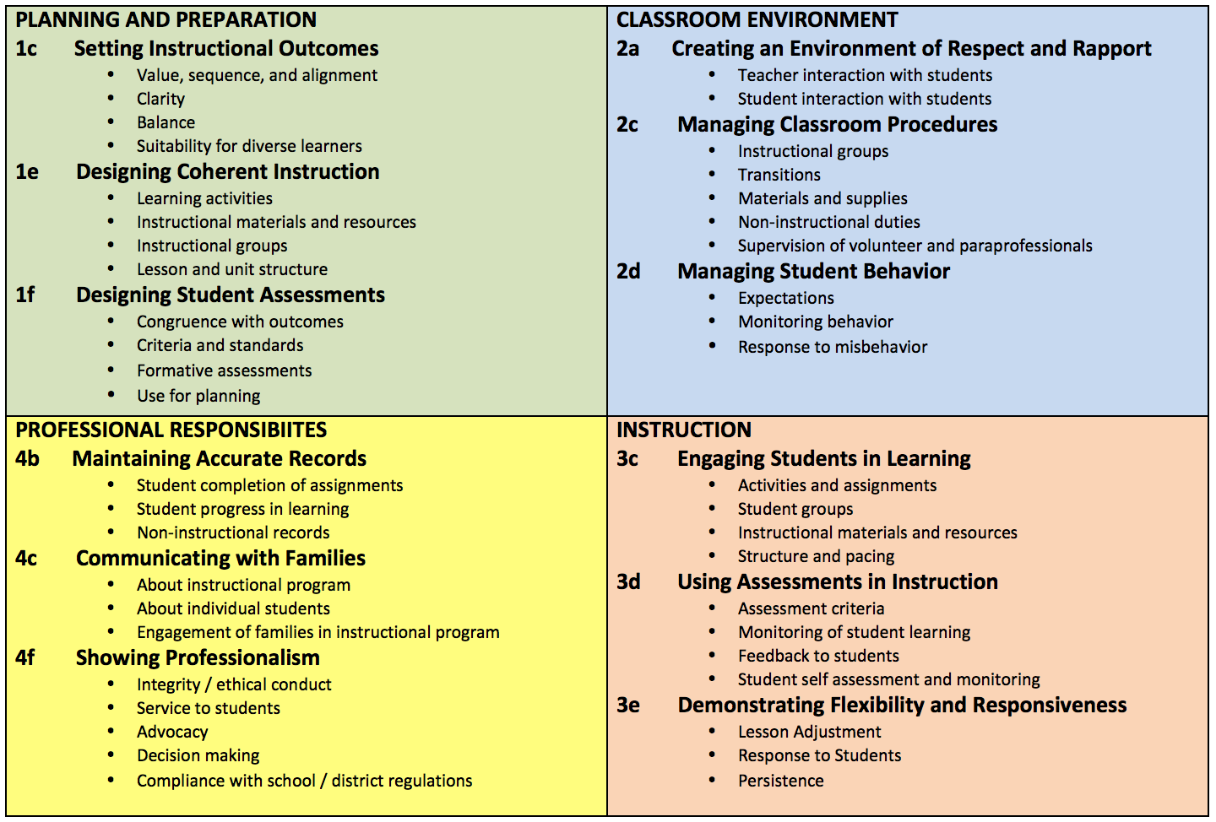

**Stakeholder Participation**

Yukon Koyukuk School District underwent a two-year process with a committee comprised of all stakeholders groups. The YKSD Evaluation Committee included teachers, principals, district office administrators, parents, and representatives from the bargaining unit. Input was sought from groups through direct meetings, parent input through CSCs, and numerous meetings of the committee. A list of participants in the committee can be found on page two of the Evaluation Handbook. The committee met four times during the 2013-14 school year (November 21/22, February 6/7, April 17/18, June 2/3) and three times during the 2014-15 school year (October 21/22, December 12, February 25-27). The district school board was kept apprised of progress on a regular basis via face-to-face presentations and/or written reports. Individual board members had an opportunity to provide their thoughts on the redesign of the system during the face-to-face meetings.

During the 2014-15 school year, all river school teachers piloted the Danielson Framework and were provided opportunity to give feedback to the Evaluation Committee.

The evaluation documents were presented to and approved by the YKSD School Board on May 15, 2015.

All evaluation documents for the Yukon Koyukuk School District can be found at (<http://www.yksd.com/Page/514>).

**Content Standards**

The Yukon Koyukuk School District Evaluation Committee selected Charlotte Danielson’s Framework as the basis for our evaluation model (*Enhancing Professional Practice: A Framework for Teaching*, 2nd ed.). The committee has cross-walked the 12 Danielson components YKSD is implementing with the Alaska Professional Teacher Content and Performance Standards and the Alaska Cultural Standards for Educators. (<http://www.yksd.com/Page/514>)

The Yukon Koyukuk School District is implementing the following 12 components from the Danielson Framework:

**Domain 1 – Planning and Preparation**

* 1c – Setting Instructional Outcomes
* 1e – Designing Coherent Instruction
* 1f – Designing Student Assessments

**Domain 2 – The Classroom Environment**

* 2a – Creating an Environment of Respect and Rapport
* 2c – Managing Classroom Procedures
* 2d – Managing Student Behavior

**Domain 3 – Instruction**

* 3c – Engaging Students in Learning
* 3d – Using Assessments in Instruction
* 3e – Demonstrating Flexibility and Responsiveness

**Domain 4 – Professional Responsibilities**

* 4b – Maintaining Accurate Records
* 4c – Communicating with Families
* 4f – Showing Professionalism

The YKSD Smart Card can be found at (<http://www.yksd.com/cms/lib07/AK01001402/Centricity/Domain/19/YKSD%20Danielson%20Smart%20Card%20AUG%202014.pdf>)

Each component for regular education teachers has its own detailed rubric.

(<http://www.yksd.com/Page/514>)

Similar rubrics for Special Education Teachers, Counselors, and Administrators can be found at (<http://www.yksd.com/Page/514>).

**Cultural Standards**

The Yukon Koyukuk School District Evaluation Committee believes strongly that cultural learning is vital to a teacher’s ability to teach in rural Alaska. The team believes in the phrase, “Don’t teach the students about their culture, rather, use the culture to teach the students”. The committee has cross-walked the 12 Danielson components YKSD is implementing with the Alaska Professional Teacher Content and Performance Standards and the Alaska Cultural Standards for Educators.

(<http://www.yksd.com/Page/514>)

The Danielson Framework specifically addresses cultural competence in several components, which include:

* Component 1e: Designing Coherent Instruction
* Component 3c: Engaging Students in Learning
* Component 4c: Communicating with Families

Danielson states: "In learning about students' backgrounds, these teachers ensure that they are aware of relevant information about cultural traditions, religious practices, and patterns of interaction that may affect a student's classroom participation. In addition, the teachers ensure that the materials they use and the examples they employ do not refer to items or traditions unfamiliar to students, or that they explain such materials and examples fully. And they take particular care that in their communication with families, they demonstrate cultural respect." (p.33, *Enhancing Professional Practice: A Framework for Teaching.)*

**Performance Standards**

The Yukon Koyukuk School District chose twelve of the components with the Danielson Framework that correlate to the eight Alaska Content Standards for teachers. The YKSD Evaluation Committee has cross-walked the 12 Danielson components we are implementing with the Alaska Professional Teacher Content and Performance Standards and the Alaska Cultural Standards for Educators.

(<http://www.yksd.com/Page/514>)

**Levels of Performance**

The Yukon Koyukuk School District will implement an EES system with an overall goal of promoting professional growth. Each of the twelve Danielson components has a detailed rubric to give teachers a clear target to teach to and a detailed understanding of the expectations that the district has for it’s instructional employees.

The rubrics detailing each performance standard and performance level are included in the copy of Danielson’s *Enhancing Professional Practice: A Framework for Teaching* that is provided to all YKSD educators. Rubrics for the twelve components in YKSD are also included with the evaluation documents at (<http://www.yksd.com/Page/514> ). Additional details regarding critical attributes and indicators of the twelve chosen components are given to the teachers and are found on the YKSD website (<http://www.yksd.com/Page/514> ).

YKSD uses four rating levels. General evaluation descriptors can be found in the following section.

**Exemplary:** Teacher demonstrates excellent performance and/or has achieved growth that exceeds expectations.

**Proficient:** Teacher demonstrates consistently proficient performance and/or achieves growth that meets expectations.

**Basic:** Teacher demonstrates inconsistent performance and/or has achieved student growth below expectations.

**Unsatisfactory:** Teacher demonstrates unacceptable performance and/or has achieved student growth significantly below expectations.

Determination of a component rating comes from the principals’ professional use of the rubrics.

Domain ratings are determined by the component ratings in that domain.

A summary rating is determined by the domain ratings.

(<http://www.yksd.com/Page/514>)

Ratings are determined by use of the Danielson Rubric during conferences held with the teacher and administrator. Teachers will have the opportunity to provide additional artifacts.

**General Descriptors of the Four Ratings of Professional Practice**

Each component, domain, and the overall summary have four ratings of professional practice which can be characterized as follows:

**Exemplary:** Teacher demonstrates excellent performance and/or has achieved growth that exceeds expectations. Exemplary ratings often include the students taking overt responsibility and action and the words “all” or “always” in the descriptions. We abide by the phrase we heard from the Danielson trainer, “We live in proficient and visit exemplary”.

**Proficient:** Teacher demonstrates consistently proficient performance and/or achieves growth that meets expectations. Proficient ratings are actually very good and a teacher who receives that rating is doing a fine job. The words “often” or “mostly” are commonly seen in these descriptions. Again, we abide by the phrase we heard from the Danielson trainer, “We live in proficient and visit exemplary”.

**Basic:** Teacher demonstrates inconsistent performance and/or has achieved student growth below expectations. Basic ratings show improvement is needed and a teacher who receives that rating is need of coaching. The words “seldom” or “few” are commonly seen in these descriptions.

**Unsatisfactory:** Teacher demonstrates unacceptable performance and/or has achieved student growth significantly below expectations. Unsatisfactory ratings show vast improvement is needed and a teacher who receives that rating is in need of immediate coaching. There is a significant difference between “Basic” and “Unsatisfactory”. A rating of unsatisfactory indicates that the teacher may be damaging the students. The words “never” “none” or “chaotic” are commonly seen in these descriptions.

**Observation Tool**

Yukon Koyukuk School District is gathering evidence using the Danielson Framework and Observe 360 (<https://www.pd360.com>). The twelve Danielson rubrics are set up on the Observe 360 website and the principals access the website to input information gleaned from the observations. This includes both a rating and a detailed text description.

All YKSD teachers will have two formal observations each year, one in November and one in February. All teachers will receive a minimum of two walkthrough observations each month. Principals are responsible for the minimum observations, both formal and walkthrough, although teachers may receive other coaching observations from district office administrators, which are also created and stored on the Observe 360 website. After each observation, the website generates an email that informs the teacher of the document and principals are to review this observation during a coaching session within a five days.

During classroom observations, both formal and informal, evidence will be gathered that specifically correlates to the Danielson Evaluation Instrument. These will result in a collection of specific evidence, to reside in the educator’s file, to be used both for a feedback conference and in the summative evaluation.

**Student, Parent and Community Input**

The Yukon Koyukuk School District provides student, parents and community members the appraisal forms for input on teachers and administrators. These forms are given out during Parent Teacher Conferences twice each school year. The forms also are posted on the district’s website. (<http://www.yksd.com/Page/283> )

Schools send out multiple notifications to families and the communities reminding them the forms are available throughout the course of the school year. Hardcopies are also made available in every school office. Completed surveys are collected by the principal at each site and are sent to the district office to be considered and shared as appropriate during personnel summary evaluations.

**Other Information**

Summary evaluations will take into account a number of items beyond formal observations. Items will include informal observations, walkthroughs, pre- and post- observation conferences, stakeholder surveys, teacher portfolios and (starting in 2016-17) student growth data. Teachers are encouraged to maintain a portfolio in order to keep hard copies and support their ratings on each of the twelve components. Teachers receive professional development on the possible documentation that may support their claims in each domain. (<http://www.yksd.com/Page/514> )

**Teacher Training**

All staff will receive annual training on the components and requirements of the evaluation system. All teachers will receive an electronic copy of the evaluation handbook (<http://www.yksd.com/Page/514> ) (and will participate in professional development to be conducted by the Director of Curriculum and Instruction throughout the school year. These trainings may encompass information on the evaluation process itself or the twelve Danielson components on which each YKSD certified employee is evaluated.

Professional development for the YKSD Educator Evaluation system has occurred several times over the last few years in various ways.

* In-service (Each fall)
* Video trainings during our Wednesday Collaborative Meetings (web add)
* Face-to-face trainings on site (web address)

Professional development for 2015-16 will occur during the annual fall in-service (August 17-22, 2015) and in several VTC trainings through the school year.

(<http://www.yksd.com/Page/620> )

**Evaluator Training and Inter-rater Reliability Training**

In addition to the training that all teachers receive, all administrators have received supplemental training on the YKSD Educator Evaluation System, in depth analysis on the twelve Danielson components, skills to be used during observations, Observe 360, and inter-rater reliability.

* YKSD Educator Evaluation System
* The twelve Danielson components - Administrators were given extensive training by Melissa Linton during the 2013-14 school year and follow up training by the Director of Curriculum and Instruction during the 2014-15 and 2015-16 school years. The follow up training generally occurs during our Principal Saturdays, which take place once each quarter.
* Observe 360 (<http://www.schoolimprovement.com/products/observation-360/> )
* Inter-rater reliability (<https://vimeo.com/album/2717274>)

Four of our seven principals and three of our directors are members of the Evaluation Committee. The have received extensive training in the Danielson Framework and the evaluation system itself.

YKSD’s inter-rater reliability is ensured through intensive training that began in the 2014-15 school year and continues throughout the 2015-16 school year. We began with in-depth analysis of each of the twelve components and their rubrics, then practiced by observing the same classroom videos found on (<https://vimeo.com/album/2717274>) which is *The Intersection of Danielson’s Framework and Workshop Teaching*, created by Columbia University’s Teachers College Reading and Writing Project.

Inter-rater reliability training dates:

* May 26-29, 2015 – Principal Training
* August 6/7, 2015 – Principal In-service
* September 12, 2015 – Principal Saturday
* December 5, 2015 – Principal Saturday
* January 23, 2016 – Principal Saturday
* March 5, 2016 – Principal Saturday
* April 9, 2016 – Principal Saturday

Inter-rater reliability will be verified by the ongoing practice during Principal Saturdays.

**Student Learning Objectives**

**Overview of Student Learning Objectives**

Each teacher will implement Student Learning Objectives (SLOs) in order to measure the academic growth of the students in that teacher’s classroom. Each teacher will submit 2-4 SLOs each year. Each SLO must have a pre-test and a post-test in order to measure the growth of each student covered by the SLO. One of the SLOs must use AMP scores as the basis for student growth measurement. The other SLO’s are based on assessments at the discretion of the teacher with approval from the district office.

**Student Learning Performance Ratings**

Each teacher will receive a rating based on the percentage of the students in their class that meet their target growth. The student learning data rating percentages established by the school district are as follows:

Exemplary………………80% - 100% of the students listed in the SLO meet their target growth

Proficient……………….55% - 79% of the student listed in the SLO meet their target growth

Basic………………………30% - 54% of the students listed in the SLO meet their target growth

Unsatisfactory………….0% - 29% of the students listed in the SLO meet their target growth

**Student Learning Data Procedures**

Each teacher must have 2-4 SLOs each year. These may include:

Alaska Measures of Progress data (required)

Measures of Academic Progress (MAP or PMAP)

aimsweb

Long-term assessments from district approved curriculum (ELA, Math, Social Studies, Science)

Teacher created assessments as approved by the district office

Each SLO will include a pre-test to be given at the beginning of the interval of instruction (usually in August or September) and the post-test to be given at the end of the interval of instruction. The interval of instruction may last from one quarter to a full year depending on how that particular SLO is structured.

**Educator Involvement**

Yukon Koyukuk School District underwent a three-year SLO process with a committee comprised of all stakeholders groups. The YKSD Evaluation Committee included teachers, principals, district office administrators, and representatives from the bargaining unit. Input was sought from groups through numerous meetings of the committee. A list of participants in the committee can be found on page two of the Evaluation Handbook. The committee met four times during the 2013-14 school year (November 21/22, February 6/7, April 17/18, June 2/3) and three times during the 2014-15 school year (October 21/22, December 12, February 25-27). A significant portion of that time was used to structure the SLO process.

During the 2014-15 school year, twelve river school teachers piloted SLO process during a University of Alaska Southeast class taught by the director of Curriculum and Instruction and were provided opportunity to give feedback to the Evaluation Committee.

During the 2015-16 school year, all certified employees in the district piloted the SLO process as required by the EED.

**Professional Growth and Improvement of Effective Instruction**

The Yukon Koyukuk School District will work to provide District Support for all teachers regardless of their overall summary evaluation rating. Our goal is instructional growth for each teacher and it is only through our ongoing professional development that we can help teachers achieve this.

YKSD is working towards a district wide, individualized professional growth plan for each teacher using Observe 360 and it’s sister website, PD 360, both of which are operated by Edivate.

The district will use information gathered from the EES system to give specific professional development. It is essentially RTI for teachers that result in individual growth plans for each teacher. These individual growth plans will be specific to each teacher and aligned with the Danielson components. For example, if it is determined that the teacher is struggling with component 3c *Engaging Students in Learning* via the walkthroughs and observations, then the coaching and professional development will focus on that specific need. The PD 360 website will allow YKSD to create a specific module for each of the twelve components. Creating these individual professional development classes will be the work of the Curriculum and Instruction department and will continue throughout the school year.

Results from the evaluation process will be reviewed between the educator and the Principal. Guiding questions will be incorporated into both the pre-conferences and the post-conferences to assist the educator with self-reflection of practices and opportunities for growth.

(<http://www.yksd.com/Page/514> )

Professional Development for improving teacher instruction is crucial to the Yukon Koyukuk School District’s Strategic Plan and it is only through our ongoing professional development that we can help teachers achieve this.

**Walkthroughs**

Each teacher will receive a minimum of two walkthroughs from their principal each month. The purpose of these walkthroughs is to provide an opportunity for administrators and teachers to reflect on the teacher’s current practices and to engage in a conversation to improve the teachers instructional and classroom skills to benefit both the teacher and the students. Walkthroughs generally last approximately ten minutes, but may be longer. They will focus on the two “on stage” domains from Danielson’s Framework:

* + Domain 2: The Classroom Environment
  + Domain 3: Instruction

Walkthroughs are recorded digitally on the Observe 360 website.

**Informal Observations**

A teacher may receive additional, informal observations during the school year from the principal or from visiting administrators, consultants or mentors and may result in additional coaching conversations.

**Pre-Observation Conference**

All principals are encouraged to use the district provided Pre-Conference questionnaire.

**Formal Observations**

Each teacher will receive a minimum of two Formal Observations from their principal each school year. These formal observations are generally scheduled for November and January. Additional formal observations may occur. Formal observations provide an opportunity for administrators and teachers to review in detail on the teacher’s current practices and to engage in a in-depth conversation to reflect upon the teachers instructional and classroom skills. Formal Observations generally last approximately 30-45 minutes, but may be longer. They will focus on all four domains from Danielson’s Framework:

* + Domain 1: Planning and Preparation
  + Domain 2: The Classroom Environment
  + Domain 3: Instruction.
  + Domain 4: Professional Responsibilities

Formal Observations are recorded digitally on the Observe 360 website.

**Post-Observation Feedback/Conference**

All principals are encouraged to use the district provided Pre-Conference questionnaire.

**Non-Retention**

Educators not meeting the district’s performance expectations will be provided opportunities to improve through formal Plans of Improvement. Guidance and support will be provided by the district during the course of the plan. The evaluating principal shall consult with the tenured teacher in setting clear, specific performance expectations to be included in the Plan of Improvement. The Plan of Improvement must address ways in which the tenured teacher’s performance can be improved.

If, at the conclusion of the Plan of Improvement, which must last for not less than 90 workdays and not more than 180 workdays with at least two teacher observations during the course of the plan, the tenured teacher’s performance again does not meet the district performance standards, the district may non-retain the teacher under AS 14.20.175 (b) (1)

(<http://www.yksd.com/Page/514>)

**Overall Rating / Overall Rating Including Student Data**

Under the Level of Support Determination, any educator who receives a rating of unsatisfactory in one or more components automatically receives an unsatisfactory in the domain and overall rating. If a teacher receives an unsatisfactory rating, this will trigger the specific professional development and coaching in that specific component.